COMP 3711

Assignment 1 Fall 2008

Submission Cover Sheet

Due by: October 10, 2008, Thursday, 3:30 pm

SET: 3F

Name: Doug Penner
Student_Id: A00658271

Name: Steffen Norgren
Student_Id: A00683006
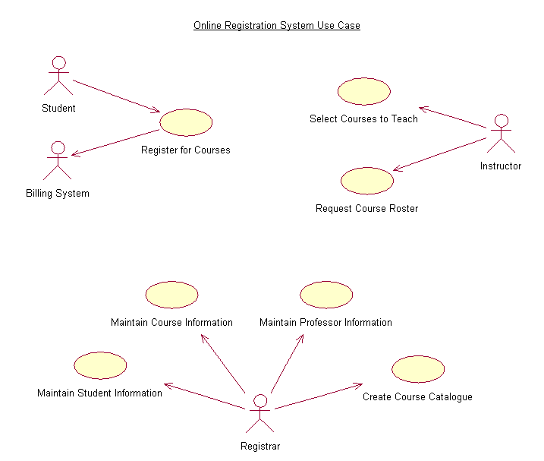
UML Domain Class Diagram
